Midterm Seatwork 2
PHP Alarm Clock Activity

Instruction:
- The student must run the given syntax to the xampp, and explain the entire syntax.

What I Did
I ran the PHP alarm clock program and tested how it worked. The program lets me set a specific alarm time. When the current time reaches that time, it should show “ALARM! WAKE UP!” in red.

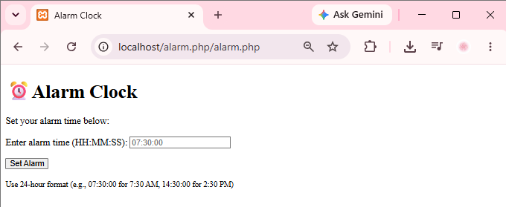

At first, I thought everything was working because the program opened normally and I could set the alarm time.

What Happened
I set the alarm time and waited for the current time to reach it.
When the time was reached, I noticed that “ALARM! WAKE UP!” did not appear.
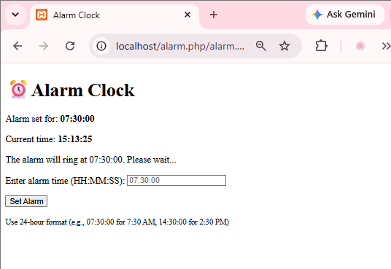
That caught my attention because I expected the message to show in red. I checked the program again and tested it one more time to make sure I was not just doing something wrong.
The same thing happened.
The Problem I Noticed
The problem I noticed was that the alarm was not being triggered when the set time was reached.
The program did not show a PHP error, so at first it looked like the program was working. But the output was not what I expected.
This made me realize that a program can run without showing an error but still have a problem with its logic.

The part I needed to look at was the condition that checks the current time and the alarm
time. If that condition does not become true at the right time, the code that displays “ALARM! WAKE UP!” will not run.
How I Understood the Problem
I understood the program like this:
I set the alarm → the program checks the time → the time reaches the alarm time → the alarm should appear.
In my test, the first two parts happened, but the last part did not.
So I knew I had to check the condition that was supposed to trigger the alarm.
This was also the part that made me realize that testing the actual output is important. If I only looked at the code and saw that there was an if condition for the alarm, I might assume that it was working. But after running it, I saw that the expected result was not happening.
What I Learned
What I learned from this activity is that not every problem will show as an error message.
Sometimes the program runs normally, but the result is still wrong. This can be a logic problem because the program is running, but it is not doing what we expect.
For me, the important part was noticing the difference between the expected output and the actual output.

Expected:
ALARM! WAKE UP! (in red)
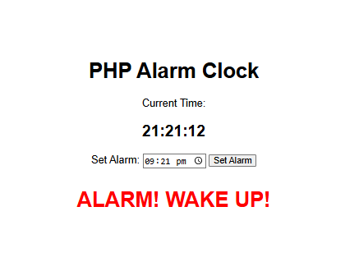

Actual:
The alarm message did not appear.
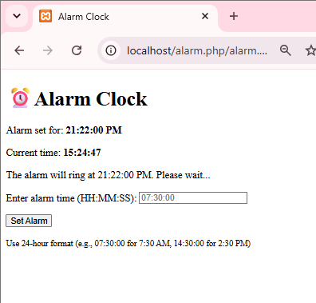

Because of that, I knew that something in the alarm condition needed to be checked.
Conclusion
My main observation from this activity was that the alarm message did not appear even when the set alarm time was reached.
Instead of just assuming that the program was correct because it ran without an error, I checked the actual result and noticed the problem.
This helped me understand that when programming, we should not only check if the code runs. We also need to check if it gives the expected output… That’s all sir!

